**Types of cloud (or) cloud deployment models**

* Public,
* Private,
* Hybrid
* Community Cloud
* **Public Cloud** – Whole computing infrastructure is located on the premises of a cloud computing company that offers the **cloud service**.

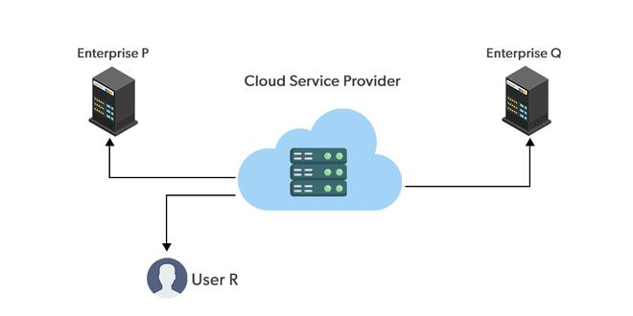

* **Private Cloud** – Hosting your entire computing infrastructure yourself and is not shared.

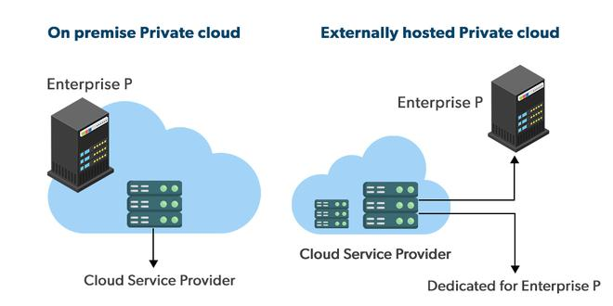

* **Hybrid Cloud** – using both private and public clouds, depending on their purpose.

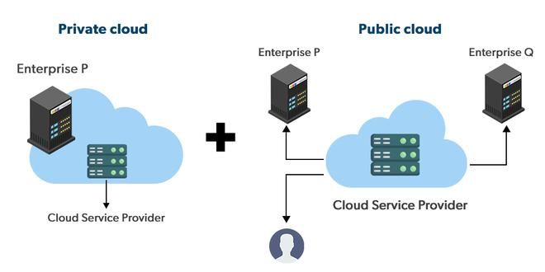

* **Community Cloud** – A community cloud is shared between organizations with a common goal or that fit into a specific community (professional community, geographic community, etc.).

